Contract
- Owner agrees to pay the rate for boarding in effect on the date pet is checked out of the Resort. Check-out time at the Resort is 12:00 pm. If pet is picked up after 12:00 pm, $22.00 extended stay fee charges will be incurred per pet. Owner further agrees that the pet shall not leave the Resort until all charges are paid to the Resort by Owner. If Owner authorizes another person or persons to pick up pet, the Owner will prepay at check-in or hereby gives Resort permission to charge Owner’s credit card number provided at time of check-in. Cancellations require a 48-hour notice or a $30.00 cancellation fee per dog suite will be charged or a $15 fee per cat condo. Early pick up of guests greater than one day will be charged a fee equal to one night’s stay. During holiday peak seasons, there is a non-refundable deposit equal to one night’s stay for any cancellation. During holiday peak seasons, early pick up of guests will be charged for the entire reservation.
- Owner further agrees to pay all costs and charges for special services requested, and all veterinary costs for the pet during the time said pet is in the care of the Resort.
- Monthly flea/tick medication is required for your pet. If fleas/ticks are detected upon arrival at the Resort, or at any time during the pet’s stay at the Resort, the pet will be treated by the Resort, and the Owner will be charged accordingly.
- By signing this Contract and leaving his or her pet with Resort, Owner certifies to the accuracy of all information given about said pet.
- Resort shall exercise reasonable care for the pet delivered by the Owner to Resort for boarding and grooming. It is expressly agreed by Owner and Resort that Resort’s liability shall in no event exceed the lesser of the current chattel value of a pet of the same species or the sum of $200.00 per animal boarded. Woof & Whiskers Resort will not be held liable if a pet should die from old age or natural causes during his/her stay at the Resort.
- The Owner agrees to be solely responsible for any and all acts or behavior of said pet while it is in the care of the Resort. If pet damages Resort property or harms another pet, Owner will be charged for any and all costs relating to such damage.
- Owner specifically represents that he or she is the sole owner of the pet, free and clear of all liens and encumbrances.
- Owner specifically represents to Resort that the pet has not been exposed to rabies or distemper within a thirty (30) day period prior to boarding.
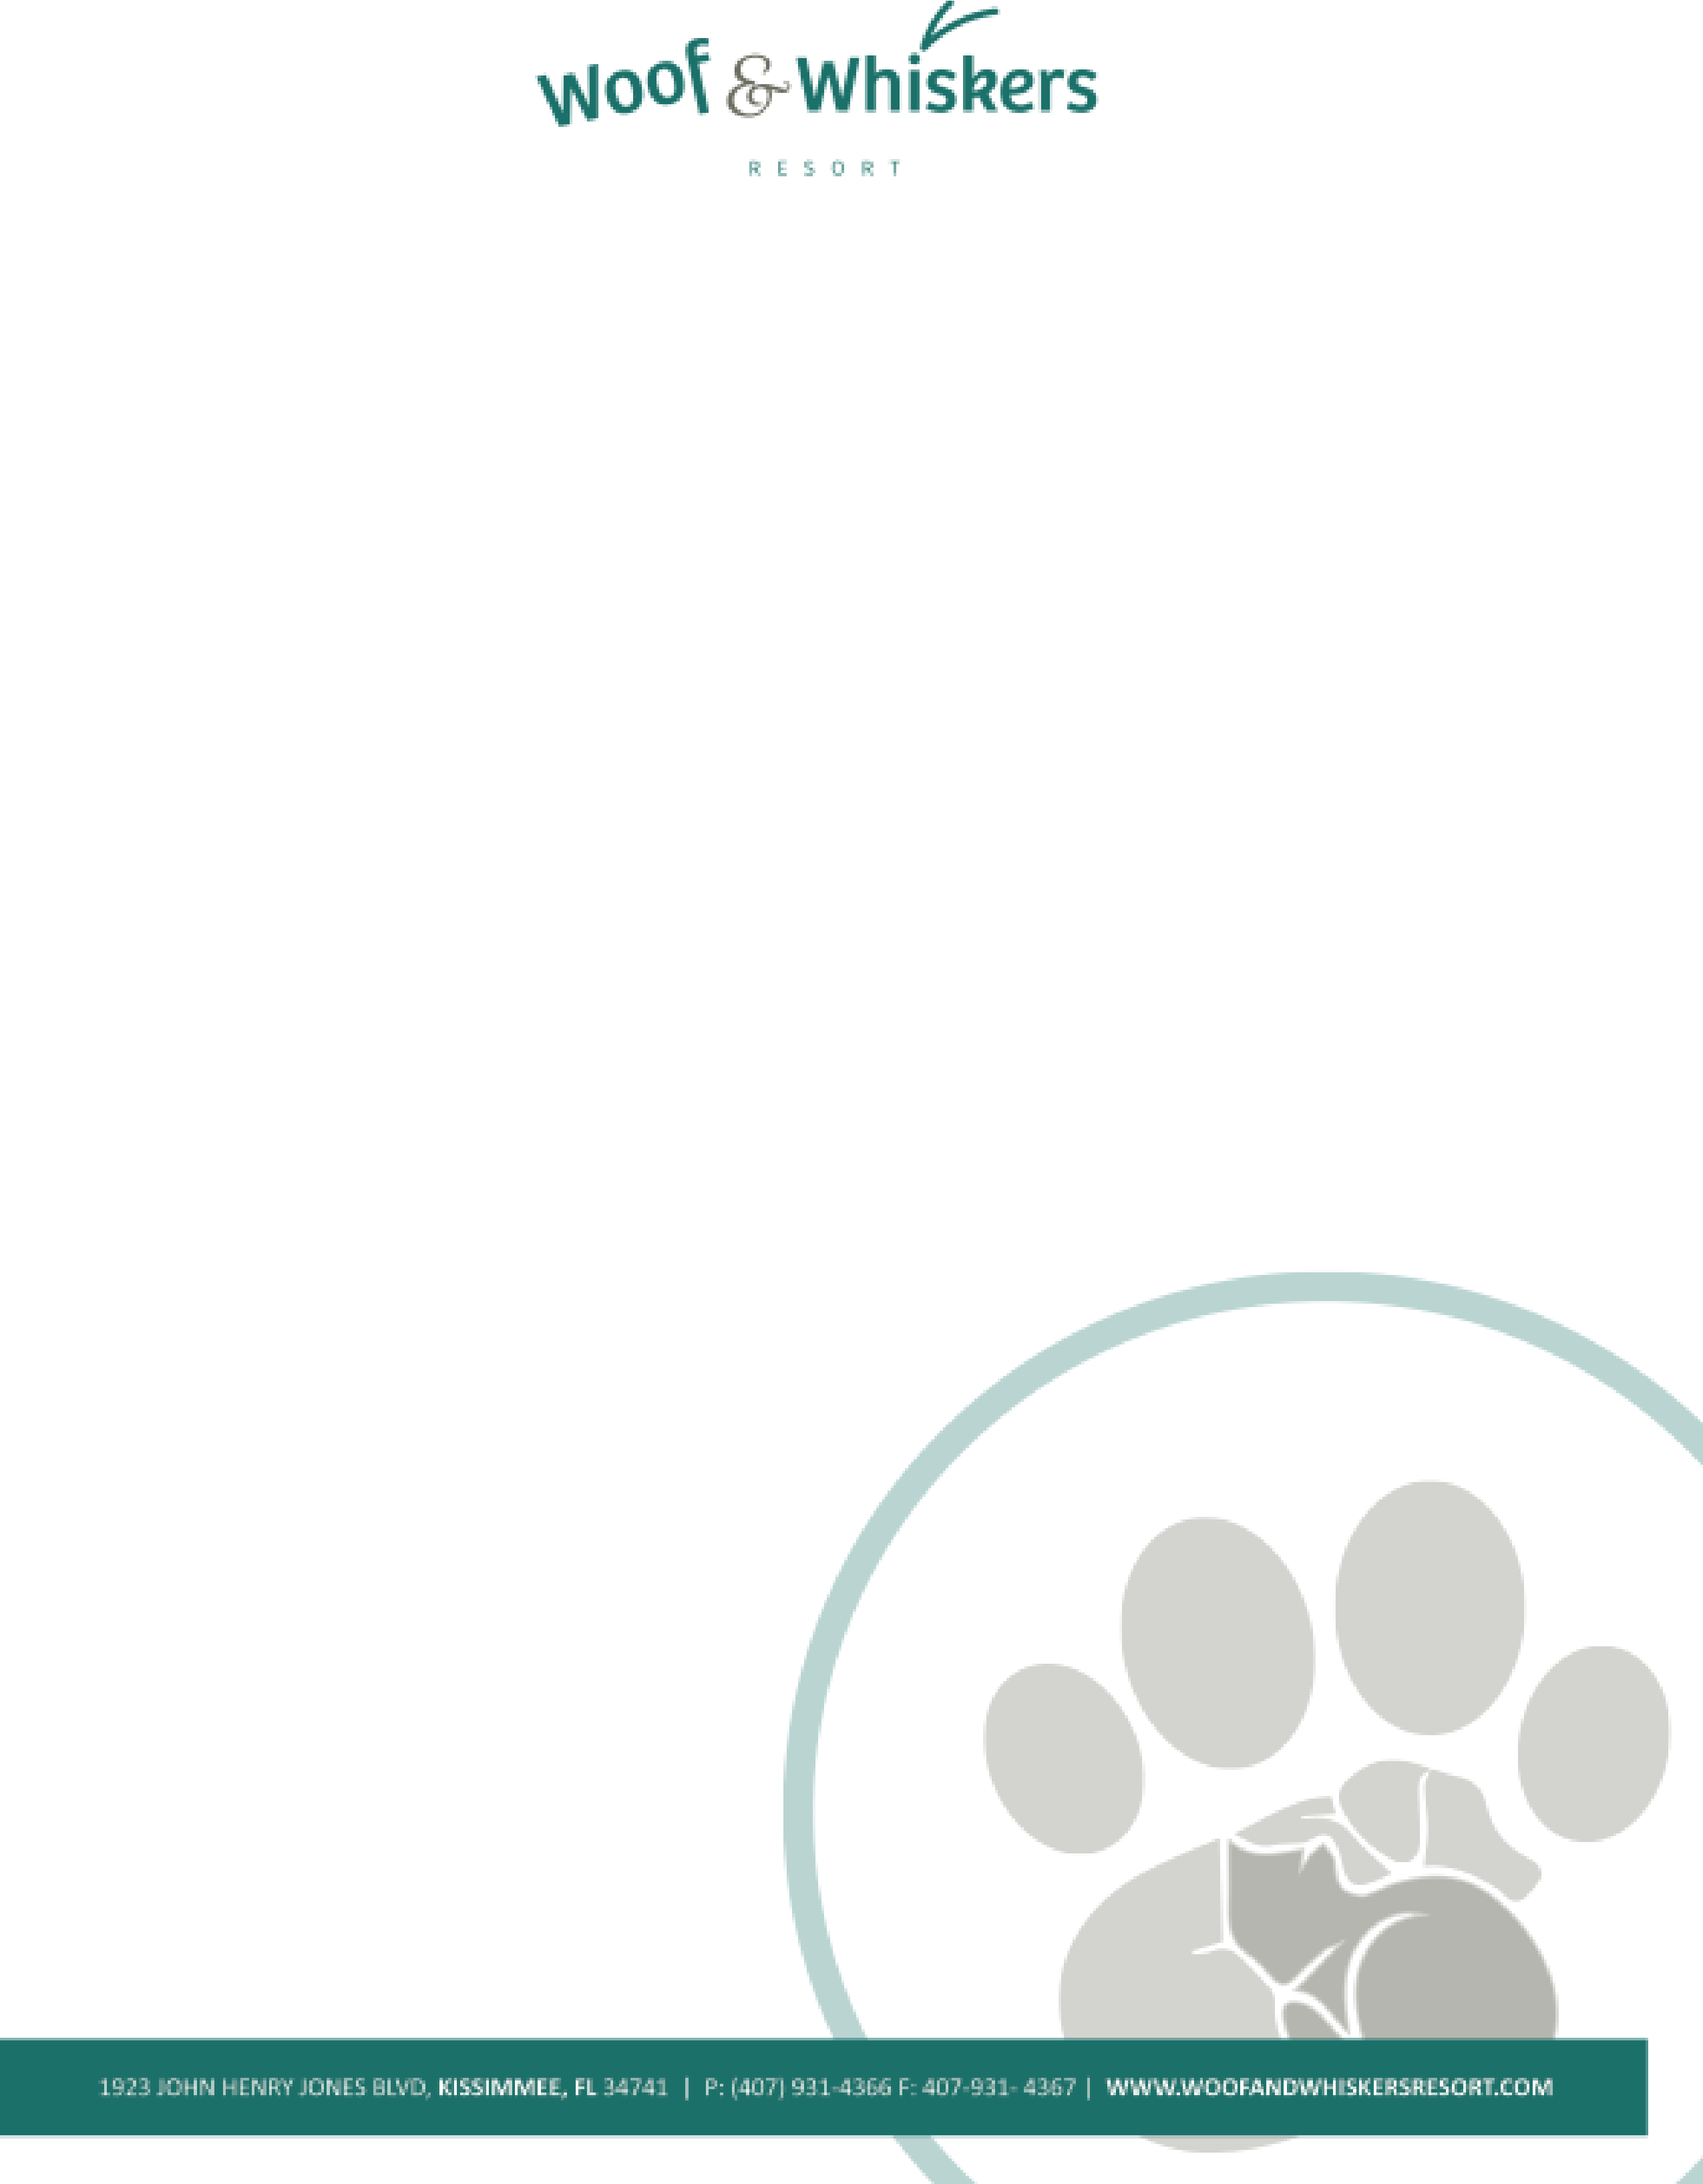
- All charges incurred by Owner shall be payable upon pick-up of pet. The Resort shall have, and is hereby granted, a lien on the pet for any and all unpaid charges resulting from boarding pet at the Resort. The Owner hereby agrees that in the event the boarding charges are not paid when due in accordance with this Contract, the Resort may exercise its lien rights upon ten (10) days written notice given by Resort to Owner by certified mail to address shown on Contract. Resort may dispose of pet for any and all unpaid charges, at private or public sale, in the sole discretion of the Resort, and Owner specifically waives all statutory or legal rights to the contrary. If such sale shall not secure a price adequate to pay such costs of boarding or other charges delinquent, plus costs of sale, then Owner shall be liable to Resort for the difference. All monies realized by Resort at such sale, over and above the charges due and costs of sale, shall be paid by Resort to Owner.
- The Owner hereby agrees that it will notify the Resort prior to scheduled departure date if a late departure is needed. If the Resort is not notified regarding a late departure and the pet is not picked up from the Resort for a period of three (3) days after scheduled departure date, the pet will then become the property of the Resort. The Resort may dispose of the pet at private or public sale, in the sole discretion of the Resort, and Owner specifically waives all statutory or legal rights to the contrary.
- If pet becomes ill or if the state of the animal’s health otherwise requires professional attention, the Resort, in its sole discretion, may engage the services of a veterinarian or administer medicine or give other requisite attention to the animal, and the expenses thereof shall be paid by the Owner. If pet needs to be taken to vet, a transportation fee of $25.00 will be charged to the Owner.
- By choosing the “group playtime” package, Owner gives permission for pet to socialize with other pets. If the pet becomes aggressive during playtime, he/she will be removed from the group. If the pet harms another pet during playtime, Owner will be charged for all fees associated with damages caused to the injured pet including but not limited to medication and/or veterinary charges. I understand and agree that dogs can sometimes receive minor cuts and scratches and I agree they will be treated as deemed best by staff of the resort, at their sole discretion, and that I assume full financial responsibility for any and all expenses involved.
- Two pets from the same family may share a room at the Resort, however, the Resort accepts no responsibility for damages caused if the pets become aggressive with each other during their stay.
- All puppies under the age of one year may require a quick bath before departure at the Owner’s expense. If the pet is over one year of age and makes frequent messes inside their individual room, a bath may be given before departure and the Owner will be charged accordingly.
- The Resort cannot accept responsibility for injury or damages caused by natural disasters such as hurricanes, tornados, floods, etc.
- By signing this contract, Owner hereby gives the Resort permission to photograph and video the pet during its stay at the Resort. These photos may be used on the Resort’s website pages, social media pages, and advertisements. Owner will not be entitled to any compensation for the use of these photos or videos.
- This Contract contains the entire agreement between the parties. All terms and conditions of this Contract shall apply to each and every visit, solely and collectively, and shall be binding of the heirs, administrators, personal representatives and assigns of the Owner and the Resort.
- Any controversy or claim arising out of or relating to this Contract, or the breach thereof, or as the result of any claim or controversy involving the alleged negligence by any party to this contract, shall be settled in accordance with the rules of the American Arbitration Association, and judgment upon the award rendered by an arbitrator may be entered in any Court having jurisdiction thereof. The arbitrator shall, as part of his award, determine an award to the prevailing party of the costs of such arbitration and reasonable attorney’s fees of the prevailing party.
- You agree to be contacted by the Resort via e-mail to include notifications of events and services.

Pet Grooming
- Safety - Safety comes first for both people and pets during the grooming process. You must inform the Resort prior to grooming if your pet has ever bitten anyone or has aggressive tendencies. We will stop the grooming process if we feel your pet’s behavior is compromising his/her safety or that of the Resort staff. Pro-rated charges may apply.
- Veterinary Care - Your pet’s comfort and safety are our first priority. We will make every effort to ensure your pet’s grooming experience is pleasant and safe; however, if your pet becomes ill or is hurt, Woof & Whiskers Resort, in its sole discretion, may engage the services of a veterinarian and the expenses thereof shall be paid by the Owner.
- Senior Pets & Pets with Health Problems – Grooming procedures can sometimes be stressful, especially for a senior pet or a pet with health problems, and can expose hidden medial conditions or aggravate existing ones, during or after the grooming. Senior pets and pets with health problems have a greater chance of injury; therefore, these pets will be groomed for cleanliness and comfort in styles that will not add to their stress. If minor accident or injury to an elderly or health compromised pet occurs during their grooming, the Resort will not be held responsible.
- Mat Removal – If your pet is severely tangled or matted, he/she is at greater risk of injury, stress and trauma. All precautions will be taken; however, problems occasionally arise such as nicks, clipper irritation, and mental/physical stress. Removing a heavily matted coat includes risks of nicks, cuts or abrasions due to warts, moles or skin folds trapped in the mats. After-effects of mat removal procedures can include itchiness, skin redness, self-inflicted irritations or abrasions and failure of the hair to re-grow. Shaved pets are also prone to sunburn and should either have sun screen applied or should be kept out of the sun until the hair grows sufficiently to protect the skin. As the Owner, you are responsible for the condition of your pet’s coat and the Resort will not be held responsible in the event of adverse effects of mat removal.
- Severely Matted Coats – If your pet’s coat is severely matted, and you do not want your pet’s coat shaved, the Resort reserves the right to take no action and refuse even the bathing process for your pet’s safety. Bathing a severely matted coat can cause increased matting and incomplete drying of the coat which can lead to infection.
- Summer Shaves – Shaving a heavily coated dog during the summer is not recommended. In both hot and cold weather, a dog’s coat helps regulate body heat, provide insulation and protect him/her from the sun. Coats that are shaved off, particularly on arctic breeds, may grow back patchy, uneven or not at all. If you request shaving, the Resort will not be held responsible for adverse side effects.
- Cancellations – On rare occasions, the Resort may need to cancel an appointment. Every effort will be made to contact you in advance. If you cannot keep your appointment, please call us 24 hours in advance so that we may fill your spot. The Woof & Whiskers Resort communicates via email to our customers. This is the most efficient way to keep Owners updated on special events or changes/updates to services. Owners hereby agree to be contacted via email. However, please feel free to opt out of our contact list if you do not wish to receive this information.

This is a Contract between the Woof & Whiskers (“Resort”) and the pet owner whose signature appears below (“Owner”). The following agreement pertains to overnight boarding services and/or grooming services offered by the Resort and shall encompass all pets and pertain to all present and future visits of and by the Owner.

Pet Owner Printed Name: ___________________________________________________________________________________

Pet Owner Signature: ___________________________________________________________Date _______________________

Pet’s Name: ____________________________________________Pet’s Name: _________________________________________

Pet’s Name: ____________________________________________Pet’s Name: _________________________________________

